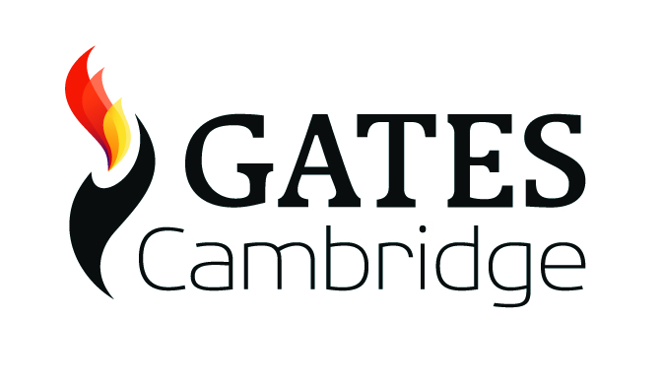
Alumni & Events Officer
Candidate pack
Overview
Salary: £29,614 to £32,344, depending on skills and experience
Contract: permanent (after successful completion of a six-month probation period).
Hours: 35 hours per week, Monday to Friday.
Location: Ground Floor, The Warehouse, 33 Bridge Street, Cambridge, CB2 1UW.
Reports to: Provost, working day-to-day to the Programme Director
Benefits:
- 33 days Annual leave per year plus public holidays
- The role holder will be eligible to join Cambridge University Assistants’ Contributory Pension Scheme (CPS)
- Discounted private healthcare is available
- Access to the University Card
- The Gates Cambridge Trust is supportive of continuous professional development for staff and suitable opportunities for training and development will be actively considered
Application deadline: midday on Friday 25 February 2022
Interviews: in Cambridge on Friday 4 March

Purpose of the role

The aim of the Alumni & Events Officer role is to support the continuing growth and development of a strong community of Gates Cambridge Alumni and Scholars that, individually and collectively, aim to improve the lives of others in myriad ways across the world.

The Alumni & Events Officer will be responsible for:
- Successfully creating, delivering and reporting on all operational elements of the Trust’s alumni relations work.

- Supporting and facilitating the Alumni Association in delivering its programme of activities.

- Supporting community building efforts for current scholars.

- Planning, executing and reporting on Trust-led events throughout the year.

- Providing support to the wider office as needed.

- Delivering the above to the highest levels of professionalism on behalf of the Gates Cambridge Trust.

Main responsibilities
Alumni relations
- Act as the first point of contact for the 1,600+ Gates Cambridge Trust alumni community, providing personalised support and service to this group.

- Create an annual programme of Trust-run alumni events, with budgets, for approval and execution. Attendance at events will be required and the role holder may be required to travel to events organised outside Cambridge and overseas from time to time.

- Be responsible for accurate, comprehensive, GDPR-compliant record-keeping of alumni contact details within the Trust’s CRM system.

- Lead on communications to alumni, including the monthly alumni e-bulletin, ad hoc emails on behalf of the Trust and Alumni Association and some social media.

- For the Gates Cambridge Alumni Association (GCAA):

  - Act as the main point of contact between the GCAA Board members and the Gates Cambridge Trust – e.g. arranging and attending monthly meetings with Co-Chairs, ad hoc meetings with other board members, responding to emails, etc.

  - Provide high quality and timely logistical support and guidance to the GCAA Board for agreed events, projects, planning and reporting.

  - Provide regular updates to the GCAA and Trust on current work and priorities of both organisations.

Current Scholars

- Lead, deliver and report on Trust-run events in Cambridge. These include:

  - Welcome Dinner for new scholars
  - Graduation Dinner for graduating scholars
  - Annual Lecture (open to all)
  - Other academic and social events as required

- Manage the application and selection process for the annual Bill Gates Sr. Prize, awarded to current scholars.

- Facilitate the transition process from scholar to alumni (working with the Programme Officer).

- Provide limited logistical support and guidance to the Scholars’ Council for certain events (e.g. sourcing and booking venues for larger events).

Reporting

- Prepare reports and updates on key work to senior staff as and when required.

Support to wider office

- Provide support to senior staff and the Programme Team during busy periods.

- Undertake any other duties and responsibilities appropriate with the post as directed by the senior management.

Ideal candidate

Education/qualifications

- Educated to at least first-degree level or equivalent - or appropriate employment experience.

Knowledge/Experience

- A good understanding of the Higher Education sector, ideally experience within an alumni relations environment.

- Experience of successfully organising events and delivering projects.

Desirable

- Experience of working with voluntary groups/volunteers.

- Experience of working with students and/or alumni.

Skills

- Excellent verbal and written communication skills - the ability to communicate effectively with people at all levels and provide effective written and oral reports in different formats.

- Expertise in building positive relationships with a range of stakeholders (e.g. alumni, students, colleagues and external stakeholders).

- Excellent organisational and time management skills and confident interpersonal skills. Ability to manage own time effectively and monitor performance against deadlines and milestones.

- Numerate and able to create and monitor budgets and always get best value for the Gates Cambridge Trust.

- High standards of accuracy, literacy and close attention to detail.

IT skills

- Excellent skills on standard office software - e.g. Word, Excel, Outlook, PowerPoint, Doodle, Zoom, etc.

- Knowledge of or ability to quickly learn in house systems (CiviCRM and WordPress website content management).

- A good working knowledge of social media.

Personal qualities

- Positive outlook and strong sense of personal responsibility.

- A proactive problem solver.

- Ability to work independently when situations demand and know when to seek advice from colleagues.

- Ability to work to tight deadlines both as an individual and as part of a team.

- Ability to work as part of a small, effective team.

- Flexibility will be especially important. The role has recently been reconfigured and is likely to evolve over time to meet the requirements of the Gates Cambridge Trust. A willingness to adapt to changing needs will be essential.

How to apply

Applications must include a cover letter, current curriculum vitae and the names of two referees (who will only be contacted in the event of an offer) and be sent to jobs@gatescambridge.org.

Please also ensure you complete the basic information form (https://forms.gle/ad5XRtmjs1PQaStTA) when submitting your application. If clicking the link above does not work please copy and paste it into your browser.

The deadline for submitting an application is midday on Friday 25 February 2022. Interviews will be held on Friday 4 March 2022.

Please note that the Trust has a responsibility to ensure that all employees are eligible to live and work in the UK.

If you have any questions about this role please email jobs@gatescambridge.org.
Background
The Gates Cambridge Trust was established in 2000 by a donation of US$210 million from the Bill and Melinda Gates Foundation to the University of Cambridge. This is the largest single donation to a UK university.
The Trust manages the Gates Cambridge Scholarship programme, which is one of the most prestigious international scholarship programmes in the world.
Each year, the Trust awards approximately 80 scholarships to international students to pursue a postgraduate degree in any subject at the University of Cambridge. Currently, there are c.250 scholars in residence in Cambridge and more than 1,600 alumni spread across the globe.
The Trust funds and works closely with the Scholars’ Council and Alumni Association to develop a global network of scholars and alumni committed to improving the lives of others.
The Trust has a Board of nine distinguished Trustees (two of whom are appointed by the Bill and Melinda Gates Foundation, the remainder by the University) who meet twice a year to decide on the overall strategic direction of the programme. The Provost is the CEO of the Trust and is supported by a Director of Finance, a Programme Director and a small administrative team who manage all operational aspects of the Trust’s activities.
Further details: www.gatescambridge.org

K:HR/Jobs/Alumni & Events Officer/2022/Alumni and Events Officer role profile Jan 2022

